AR 3000 Electromagnetic Generator Message from Antonio Romero: Well folks, as you have said I leave here a generator, checked and It works 100%, the energy production is quite high, the attractions magnetic are quite low, all because of the way the system is mounted, principle is not very complicated are simple materials to get, and logically it is variable, between poles and coils, I am explaining a connection monophasic, but logically it can be done three phase.
I have made a cut to not to extend the explanation much, and I have explained it in the simplest way and simple without getting too much into specifications, or scientific words, of way that we can all understand, the one that comes from the world of energy, like the one that comes from other types of jobs, I leave you flat with measures and others, in case you want someone to do the pieces, I hope you like it, and there you have another little grain of sand that I had kept in my trunk, since, Many years, share it, comment it and say if you like it or do not like it for me important to at least know that, come a hug for all
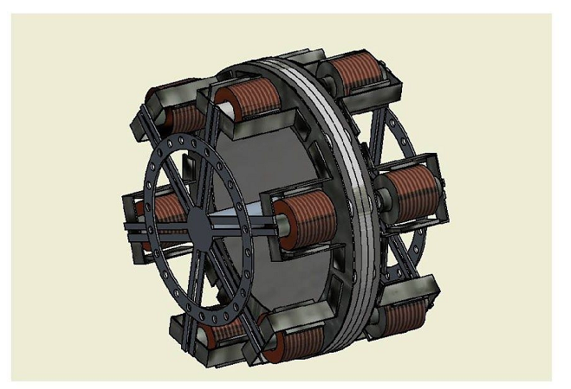
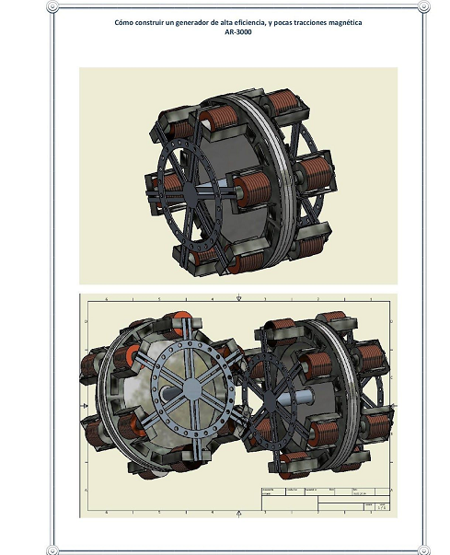
We will begin to explain Step by step, especially materials needed to assemble the AR-3000 generator, it is clear that this is a reference, which can be built under the measures that is going to comment, or logically smaller, or larger volume each person should or should build this generator for their own needs, we start with the disk of magnet supports, we take a disk with a diameter of 280 mm, we place 12 poles, in this case north, south, north, south, and so continuously, we would have 6 poles nord, and 6 poles south, 10 we put in our disk in this case rotor, we need a non-ferromagnetic material, to eliminate magnetic losses in the rotor .
Here I leave the drawing of the rotor and placement of magnets, which is clear to make a generator of high efficiency, ferrite magnets are not advised, since these magnets have very little magnetic force, advisable neodymium magnets, Other types of high magnets efficiency, The rotor is recommended with a minimum thickness of 20 mm, material materials Rigid materials: STAINLESS,
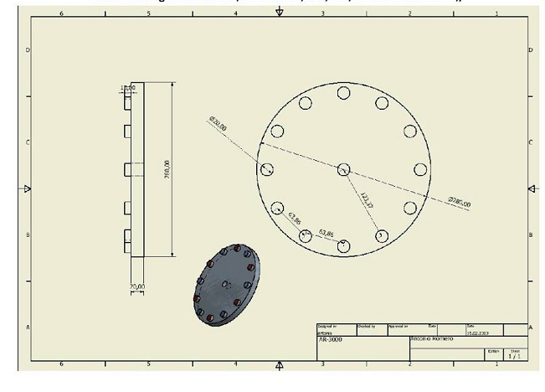
Next step, it would be to cut a steel ring of 280 mm on the outside, and the inner part 220mm and 3 mm thick, This ring is placed on top of the magnets "the purpose of the function of this ring is to cancel magnetic attractions on the When our coils have a magnetic continuous flow in the ring, it contracts a magnetic reduction or, say, a reduction of traction, because we would not have a braking or an entry shock in the magnet, nor would it tampon an output pull of the magnet with our In addition, as this ring is continually wiped, the core of the Patin Coil would practically be placed on this mattress, which is why it would be magnetic this sheet .

That is to say, our core would slide over this child absorbing all the magnetic flux without having the typical attraction of magnetic fluxes.

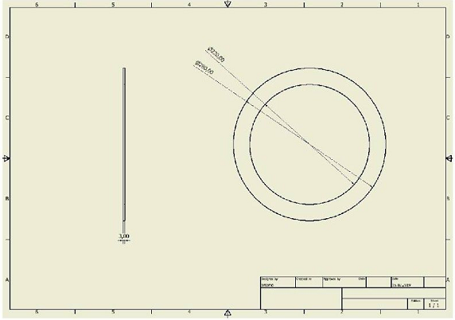

Next step would be to fix the ring on the magnets either by screwing it operating to let stable on the magnets

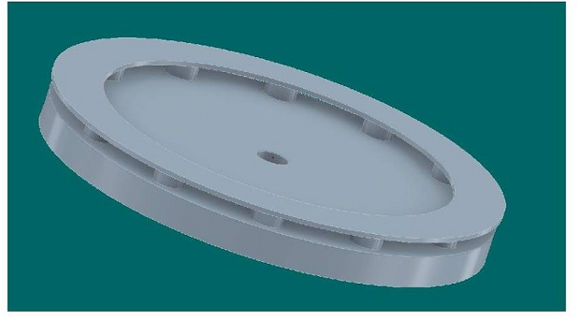

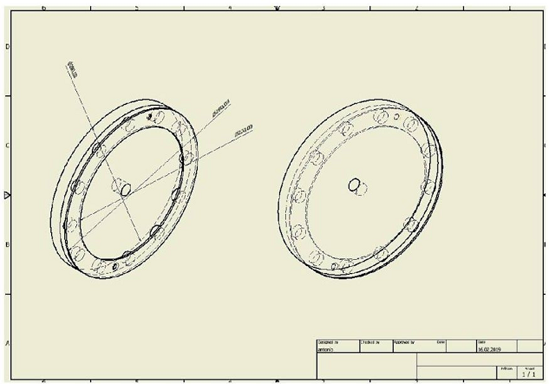

axle support 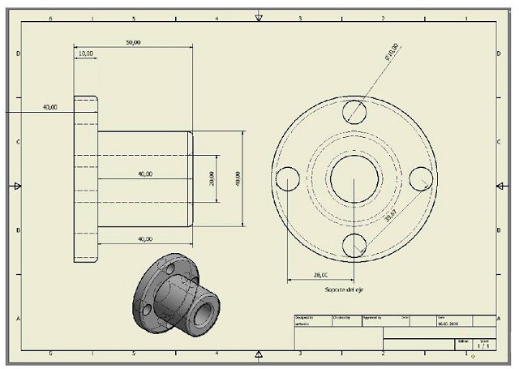
The support of the shaft will be fixed to the rotor of IOS magnets, well glued or welded …can be of PVC, PLA STEEL.the function of this support will be to fix the rotor so that it can be moved by our Movement System. since the coils are fixed so as not to have to work with brushes,

Coil suport
The bobbin support will carry a bearing placed in the center, since this system will remain fixed to maintain the coils, without any rotation, the drill centers a reference placed, but logically each one will have to open this drill depending on the bearing that we put it in the center, since they exist of different "meters, here we carry 1 of 40x20 mm, in case we change the diameter of the axis Remember that it will have to be changed also in the Rotor MATERIALS-PVC-PLA-POLIAMITO any QUIER MATERIAL RIGID

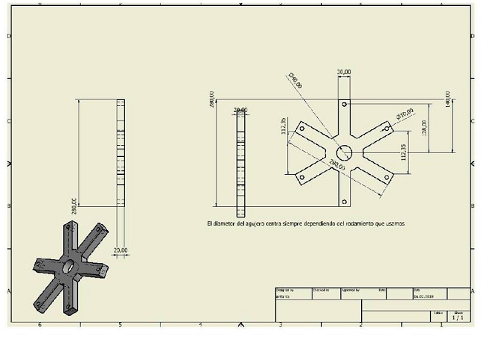
Build two rings as support for the bearings, to fix it inside our star in this case the coil support
The core of the coil, can be steel, ferrites, ferro-magnetic material
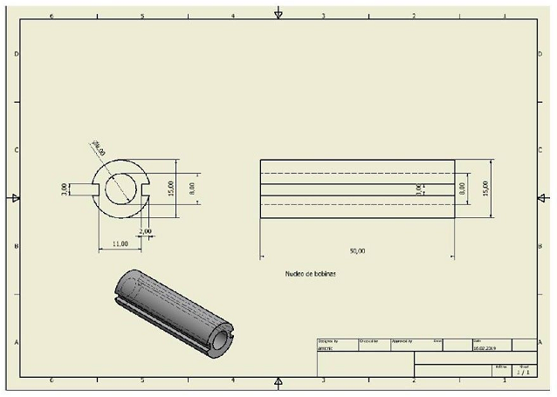
The core has a solid aluminum bar, fixed at the center about 10 mm apart from the induction tips, approximately 7x35 mm
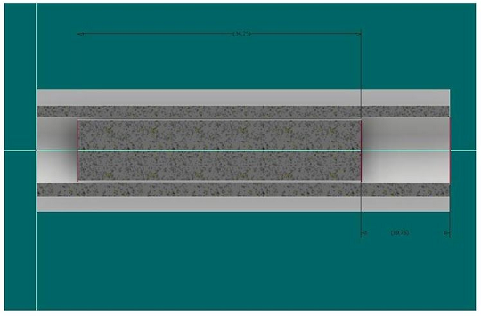

Nucleus with inducing crown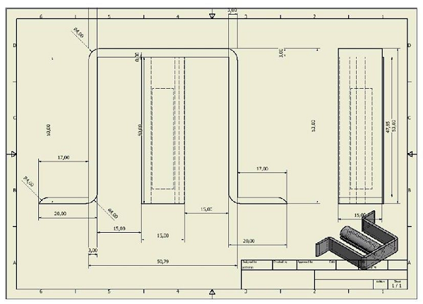
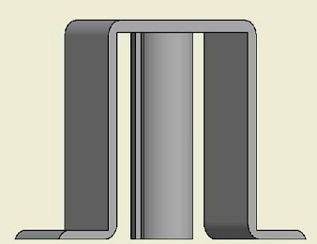
Core including the inductor crown, the crown must be the same material that we make our core. It is advisable to first roll the coil in the central core, and then place the crown on top, so we have the option to guide our coils easily, we must be careful that the legs of the crown that fall down never will be long er than the central nucleus, The width always using the same width that we use as the central core

coil must have 6 conductors of 3x0.80 and 6 conductors of 3x1.20

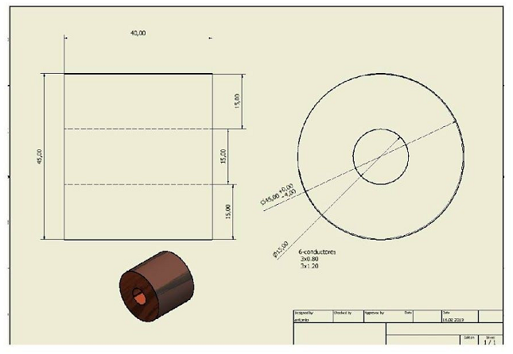
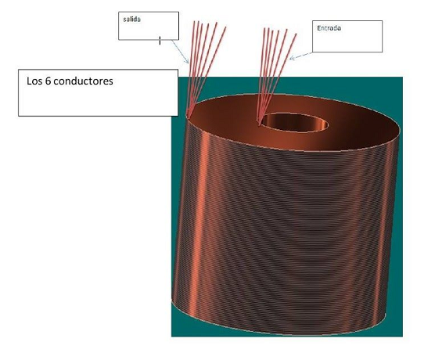

COIL MOUNTING
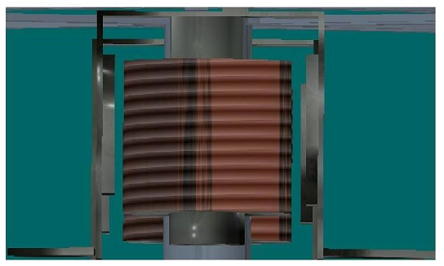
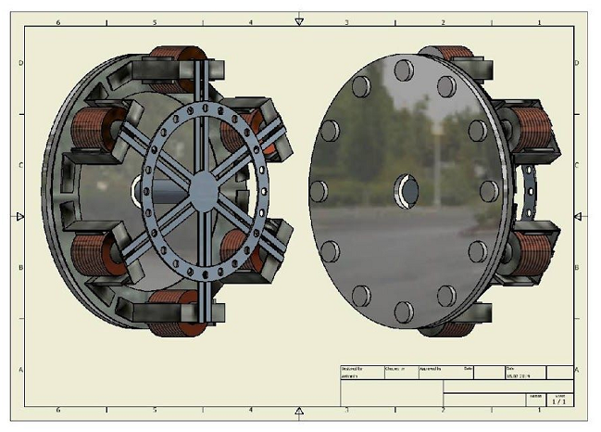

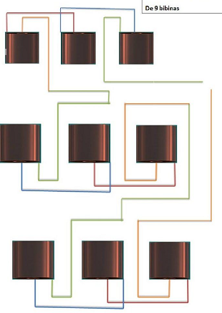
This connection can be made with more or less coils, advisable for the production of direct current, also for alternating current, monophase

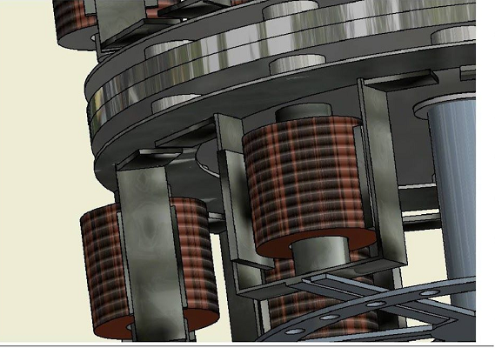
Here we have a summary of how to assemble an effective generator, and good energy production, in addition to low tractions for its construction, to answer surely the question of all or let's say the question of the century, is the usual how many strengths they have. that is the magnets ", that is free for each one depending on the energy that I want to produce, I would advise neodymium magnets with a minimum of 20 kg of force, amount of copper, if we take the measurements of the coil and calculate we can extract the quantity of copper what we need, logically in this dimension that we have mentioned, the amount of copper will depend on how the coils are assembled, if they are going to fit well, place everything well, or will be placed in a less controlled area, Estå Of course, less copper enters, I would say approximately 150 to 200 grams of copper, distance from the inductor plate to the nuclei, you can play with the distances and I would advise approximately 2 mm, but depend If we use the induction sheet that we take, that is the material we use, we will have the effect, it is not advisable to pick up sheets with nickel, or with 10 possible clean paints, and the most pure steel possible, since from there we have to play with the distances between core and inductor plate,

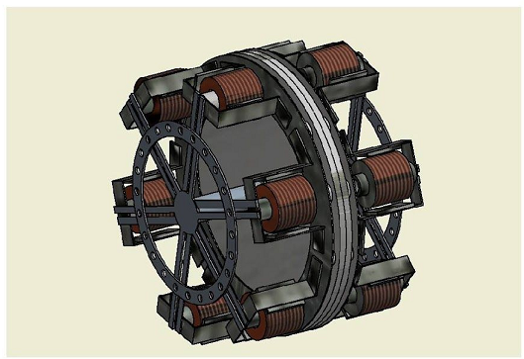
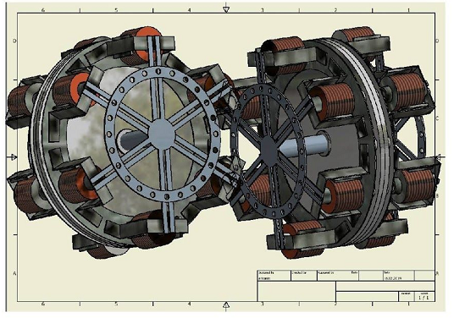
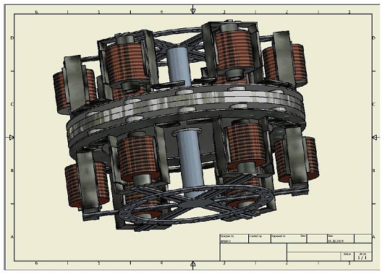

Electromagnetic generator for experimenting with it
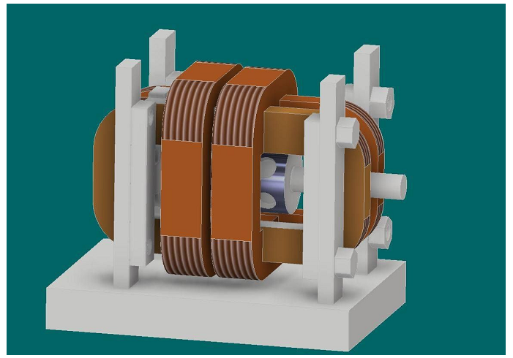
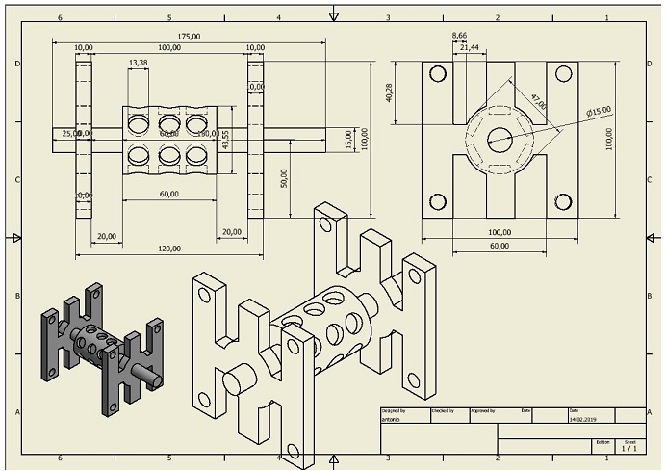
Well to explain a little the operation of this system, if you look well the two central coils are picking up the magnetic flux of the rotor, between coil and coil there is a space where the flow passes, and we would be inducing on the outer coils, but the two coils When we pick up the magnetic flux and make the transformation into energy, an automatic magnetic flux is mounted around the coil, 10 we will be collecting with the two external coils, that is to say that in this case the two outer coils, will produce maybe the same or more energy than the two central coils, then it is advisable to put an aluminum box on top, if it can be a box of a thick aluminum rim, or several plates or aluminum plates one on top of it because it is already known Passive aluminum has no effect with respect to energy, but when we activate a magnetic flux, it usually has the repelling effect, if we put it very close to the river. We have to be careful because it can not be used as a brake, as some think that we can activate the rotor and eliminate an attraction and increase the rotation, otherwise it acts as a brake, but if we remove it, and it is closed, at the moment that is activated, by this magnetic field that is mounted inside the box already discussed, what we do is to hold the magnetic flow inside the system, and we would have practically a bounce of flows in different directions, which our coil pick up and apart from this magnetic flux and 10 we use to produce energy, With respect to the motion propeller if we want to do with air, or maybe move it with water, I would advise the wheel of a bicycle, which we have in different sizes, for the simple reason that it would be counterbalanced and we would have a good structure
easy to achieve, and perfect for the project, remember a Thing this system depending on the power of magnets quantity of copper and volume of the system, can give us very good solution in everything
that place where there is no energy, simple easy simple to assemble, since it can be done
any material, even wood if it is necessary painting the good so that it is not thrown away
with the rain, and copper you can catch the recycling if you need it too, the movement as
has already commented on an old wheel of a bicycle for example, in order there I leave you some
planitos as base, logically after each one can build it the volume he wants
I think it's a system, quite simple



